3D print training modules for electric-electronic teachers in vocational high schools

(2019-1-TR01-KA202-07433)

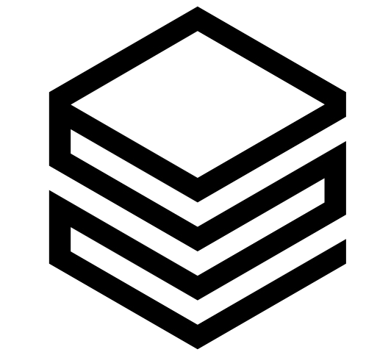

IO1: ECVET based knowledge and skills progression framework

Start date: 01-12-2019
End date: 30-06-2020

Leader: Vienna Association of Education Volunteers

Index
1. Preface 3
2. Introduction 5
3. Learning outcomes 7
4. Equipments and software benchmarking 17
4.1 Comparison of 3D modelling programs 17
4.2 Comparison of slicing programs 20
4.3 Comparison of 3D printers 21

1. Preface
Professional development of vocational teachers is the key element for ensuring the quality and relevance of the vocational and technical education both in school and work based. Using the new technologies like as 3D print and prototyping in VET high schools will strengthen the links between school education and labour market. There is not a developed curriculum for 3D print training modules for electric-electronic department to implement 3D modelling to engage young minds and increase speed & creativity in school lab. 3D printing technology is important to today’s VET students because they will be tomorrow’s employees.

3D printing is everywhere, impacting industries such as healthcare, aerospace, manufacturing and practically any other areas. However, adoption of the 3D printing technology is still relatively low for educational purpose. Despite potential benefits, there is not a unique teaching material for the integration of 3D printing technology into the electric-electronic education in vocational high schools.

With the expansion of the applications of 3D printing technology throughout electric-electronic industry, it is important that VET teachers start to increase design and technical skills required to harness this technology.

VET, together with the overall education and training systems, will need to support the competitiveness and innovation of European economies. Development of skills anticipation is necessary by using updating curriculum accordingly for the effective learning according to the electrical-electronic sector demands and new technologies.

Teachers’ role is changing as a result of new approaches to learning. With a growing attention to active learning, responsibilities are shifting from the VET teacher to the student, with the teacher becoming a facilitator of learning processes rather than a transmitter of expert knowledge. Self-directed learning is apparently a necessity for an increasing part of the population in changing societies.

"3D print training modules for electric-electronic teachers in vocational high schools" project will develop a unique educational material for the purpose of the professional 3D printing technology implementation in school atmosphere by VET teachers. It will help VET teachers:
- To provide visual materials in classroom,
- To seize engagement of students,
- To enhance hands-on learning with realistic models,

The project will developed the following intellectual outputs for electric-electronic teachers in vocational high schools.
- IO1: ECVET based knowledge and skills progression framework
- IO2: 3D print training module for electric-electronic course in vocational high schools
- IO3: 3D print training module online learning platform

Main aim of the project is to develop ECVET based on unique educational materials for up skilling of electric-electronic teachers in vocational high schools.

Educational materials development process will include four quality design principles for teaching. These are:
1. Competency-based system
2. Active ownership
3. Development of rigorous high level skills
4. Responsiveness

2. Introduction
Main aim of this output is to develop ECVET based unique training curriculum for 3D print training modules to use at vocational high schools by electric-electronic teachers.

ECVET based knowledge and skills progression framework will include learning outcomes, curriculums, technical requirement report with equipments and software benchmark.

ECVET based knowledge and skills progression framework will be split into 6 units. These are:
- Introduction to 3D printing
- 3D printing process
- Creation a model to 3D print
- Developing modelling skills
- Optimization
- 3D printing for electric-electronic

Within these three strands, the knowledge and skills framework will be designed into intermediate level to allow its structuring and progression. A series of discrete knowledge and skills will be listed as learning outcomes. These will be used to plan electric-electronic lessons with assessment opportunities for new curriculum.

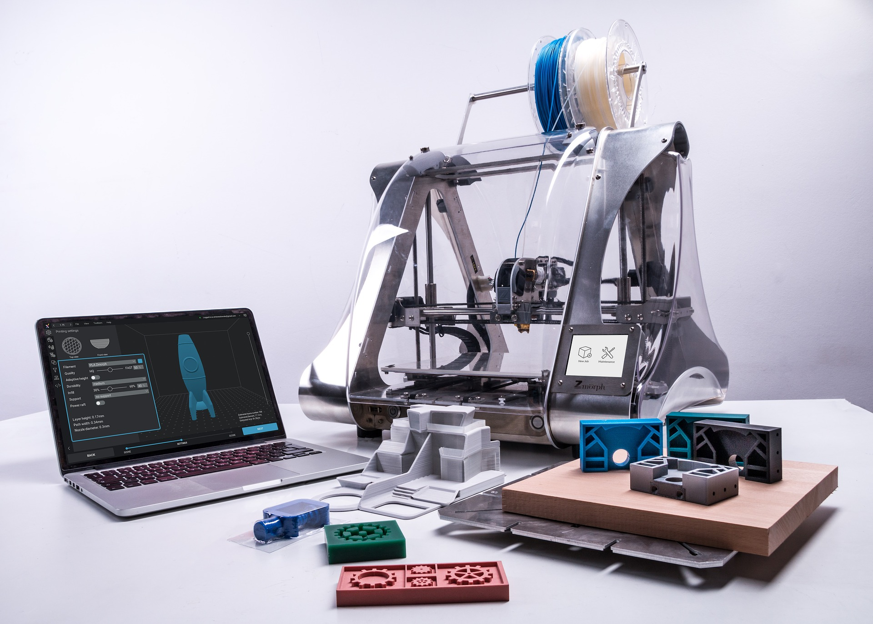

Elements of innovation:
This output will be a unique ECVET based training curriculum for 3D print training modules to use at vocational high schools by electric-electronic teachers to use in 4 countries.

Expected impact:
- Increased knowledge of VET teachers about 3D print processes, designing for 3D printing and slicing models, 3D modelling.
- Greater understanding of 3D printing technical requirements with equipment and software benchmark
- Increased practice level of VET teachers to effective use of learning outcomes and curriculum with assessment opportunities.

Transferability potential:
Developed learning outcomes, curriculums, technical requirement report with equipments and software benchmark can be easily adapted to other VET programs such as mechatronic, machine, automation, engine technologies. Its level can increase to advance level to use in vocational colleges and universities.

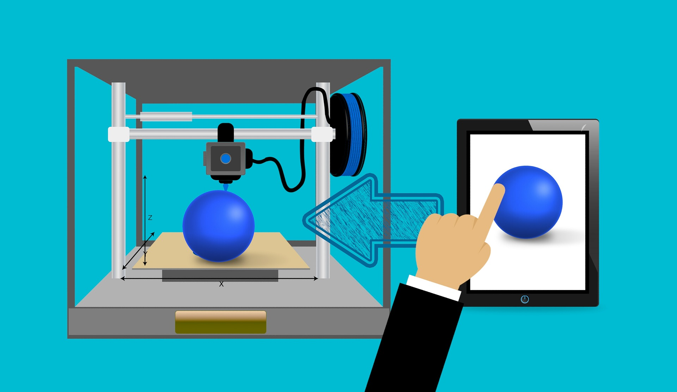

3. Learning outcomes
Learning outcomes are statements that describe the knowledge, skills and competence learners should acquire by the end of a particular assignment, class, course, or program, and help learners understand why that knowledge and those skills will be useful to them. They focus on the context and potential applications of knowledge and skills, help learners connect learning in various contexts, and help guide assessment and evaluation.
Those developed learning outcomes are measurable skills, abilities, knowledge or competence that the learners demonstrate as a result of completing a given course or class. The effective learning outcomes are developed through 6 units learner-oriented; they describe what both students have to learn and what the instructor will teach them.

Measurable and achievable in nature

Skills, abilities, knowledge and competence

Learning outcomes

Unit 1 | Introduction to 3D printing
Responsible partner | P4, Vienna Association of Education Volunteers - Austria
Table of content | 1.1 Overview of 3D printing technology  1.2 Materials used in 3D printing  1.3 Components of 3D printers  1.4 Safety issues in 3D printing  1.5 3D printing application fields  1.6 3D modelling and printing software  1.7 3D printing file formats
Training workload | Theoretical part (hours): 5, Practical hours:2
Learning outcomes | Knowledge:  - Tell the differences between 3D prototyping machines (CNC) and 3D printers  - Describe and list the different 3D printing technologies  - Sequence strengths and weaknesses of 3D printing technology  - Find the right 3D print materials to use in different projects  - List the mechanical and electrical components of 3D printers  - Tell the safety issues and precautions in 3D printing  Skills:  - Use different 3D print technologies such as FDM and SLA  - Prepare the right materials used in 3D printing such as PLA filament, ABS filament  - Show mechanical and electrical components of 3D printers  - Operate safety instructions in 3D printing  Competence:  - Be responsible for the 3D printing technologies  - Comply safety instructions in 3D printing  - Ensure the right software and 3D printing materials for own project
Assessment type | Quiz (10 questions)

Unit 2 | 3D printing process
Responsible partner | P2. Kaunas Science and Technology Park – Lithuania
Table of content | 2.1 Installation and calibration of the machines  2.2 Preparations of the machine for printing (material loading, printing bed, environment)  2.3 Adjustment of printing process parameters (speed, temperature, etc)  2.4 Post processing (part removal from the machine, additional post processing works, etc)  2.5 Quality control of 3D printed part (repeatability, accuracy, etc).
Training workload | Theoretical part (hours): 10, Practical hours:2
Learning outcomes | Knowledge:  - 3D printing processes: (software for 3D modelling - Solid Works (student edition), software for 3D slicing - Cura).  - 3D printing materials.  Skills:  - Operate 3D printing process.  - Operate 3D printing process with different materials.  Competence:  - Create a three dimensional object.  - Create a three dimensional objects using different materials.
Assessment type | Quiz (10 questions)

Unit 3 | Developing modelling skills
Responsible partner | P1, Yunus Emre Mesleki ve Teknik Anadolu Lisesi - Turkey
Table of content | 3.1 Orthographic Projection  3.1.1 Projection of Point  3.1.2 Projection of Lines  3.1.3 Projection of Planes  3.2. 2D and 3D Dimension  3.2.1. Dimension Tools  3.2.2. 2D Dimension  3.2.3. 3D Dimension  3.3.Sketch 2D  3.3.1 Line  3.3.2 Rectangle  3.3.3 Slots  3.3.4 Circle  3.3.5 Arc  3.3.6 Plygon  3.3.7 Spline  3.3.8 Ellipse  3.3.9 Filled  3.3.10 Text  3.3.11 Trim Entities  3.3.12 Convert Entities  3.3.13 Offset Entities  3.3.14 Mirror Entities  3.4. Boss/Base  3.4.1 Extruded Boss/ Base  3.4.2 Revolved Boss/ Base  3.4.3 Swept Boss/ Base  3.4.4 Lofted Boss/ Base  3.4.5 Boundary Boss/Base  3.5. Cut  3.5.1 Extruded Cut  3.5.2 Revolved Cut  3.5.3 Swept Cut  3.5.4 Lofted Cut  3.6. Sketch 3D  3.6.1 Filled  3.6.2 Pattern  3.6.3 Rib  3.6.4 Shell  3.6.5 Wrap  3.6.6 Mirror  3.6.7 Reference Geometry  3.7 Assembly  3.7.1 Insert Component  3.7.2 Mate
Training workload | Theoretical part (hours): 15, Practical hours:15
Learning outcomes | Knowledge:  - Draw 2D and 3D Orthographic Projection  - Describe 2D and 3D dimension  - Use 2D and 3D sketch tools on CAD software  - Name 3D objects on CAD software  - Define extruded, revolved, swept, lofted and boundary boss base  - Tell cutting tools  - Describe assembly  Skills:  - Practice to draw 2D and 3D Orthographic Projection of objects  - Operate tools of CAD software  - Create assembly and animation on CAD software  - Present extruded, revolved , swept, lofted and boundary boss base  - Show cutting tools  Competences:  - Create a three dimensional object  - Use tools of CAD software  - Manage boss  - Negotiate cutting tools
Assessment type | Quiz (20 questions)

Unit 4 | Creation a model to 3D print
Responsible partner | P3, Gheleşian Petru from ”Aurel Vlaicu“ Technological High School Lugoj - Romania
Table of content | 4.1. Steps of Part: 3D Representation of a single design component  4.1.1. Steps of Interface of Solid Workes  4.1.2. Steps of Sketch.  4.1.2.1. Steps of Line, Steps of Circle.  4.1.2.2. Steps of Smart dimension  4.1.2.3. Steps of Trim entities  4.1.2.4. Steps of Circular sketch pattern  4.1.3. Steps of Features.  4.1.3.1. Steps of Extruded Boss/Base  4.1.3.2. Steps of Revolved Boss/Base  4.1.3.3. Steps of Extruded Cut  4.1.3.4. Steps of Revolved Cut  4.2. Steps of Assembly: A 3D arrangement of parts and/or other assemblies  4.2.1. Steps of Mate  4.2.2. Steps of Linear/ Steps of Circular Component Pattern  4.2.3. Steps of Move/ Steps of Rotate component  4.2.4. Steps of Material / Steps of Select view.  4.3. Steps of Drawing: A 2D engineering, tipically or a part or assembly.  4.3.1. Steps of Sheet/ Steps of Format size  4.3.2. Steps of Projected view.
Training workload | Theoretical part (hours): 10, Practical hours:2
Learning outcomes | Knowledge:  - Accessing SolidWorks software as a 3-D design tool Designing objects in SOLIDWORKS software  - Applying Part, Assembly and Drawing in SolidWorks software  - Knowledge of working tools in SolidWorks  - Covers creation, retrieval and modification of 3-D and layout drawings using basic SolidWorks commands.  - Editting materials of parts and assemblies in SolidWorks  - Use the component library in SolidWorks  Skills:  1. Operate 3D designing software  2. Update data to 3D printing and then run it.  3. Explore ways to develop and share your design and engineering skills  4. Create parametric models of parts and assemblies  5. Generate dimensioned layouts  Competence:  1.Creating a three dimensional object in SolidWorks  2. Use common types of 3D printers in SolidWorks  3. Creating three-dimensional solid models  4. Creating three-dimensional assemblies incorporating multiple solid models
Assessment type | Quiz (10 questions)

Unit 5 | Optimization
Responsible partner | P5, REDVET - Turkey
Table of content | 5.1 Optimization in the design process  5.2 Optimization and quality  5.3 Design recommendations  5.4 Pre processing parameters  5.5 Infill design  5.6 Cost optimization
Training workload | Theoretical part (hours): 10, Practical hours:10
Learning outcomes | Knowledge:  - List optimisation techniques applied in 3D printing  - Describe 3D printing optimisation parameters  - Tell quality definition and improvement  Skills:  - Use geometrical modelling  - Do right materials selection  - Operate 3D printing process improvement  Competence:  - Be responsible for the optimisation of 3D printing processes.
Assessment type | Quiz (10 questions)

Unit 6 | 3D printing for electric-electronic
Responsible partner | ITIS Polo Tecnico “Fermi-Gadda”
Table of content | - 3D print of electric components  STL code of some examples: The plug, electric terminal.  - 3D print of electric projects  STL code of some examples: Gearbox, relay.  - 3D print of spare parts for electronics  STL code of some examples: Raspberry Pi Case-Box, knob adapter (for potentiometer), breadboard case, battery case, fan grill cover, AA battery holder, easy soldering platform, PWM circuit housing.  - 3D print of electronic projects  STL code of some examples: Robot arm, led lamp, resistor storage box, dimmer circuit box, electronics third hand soldering stand, RGB led fidget spinner.
Training workload | Theoretical part (hours): 4, Practical hours:30
Learning outcomes | Knowledge:  1. 3D printing materials.  2. Slicing techniques & materials.  Skills:  1. Problem-solving.  2. Operating 3D printing process with different materials.  Competence:  1. Using common types of 3D printing.  2. Creating a 3D object.
Assessment type | Practical exam

4. Equipments and software benchmarking

4.1 Comparison of 3D modelling programs
3D modelling is the process of developing a mathematical representation of any surface of an object (either inanimate or living) in three dimensions via specialized software. The product is called a 3D model.

Used in industries like animation, architecture, manufacturing, product iteration, and industrial design, 3D models are crucial components of digital production. That’s why choosing the right 3D modelling software is essential – it helps you to realize creative ideas with a minimum of fuss.

Finding the best 3D modelling software is not an easy task. To help you choose the right one, we have included suites of 3D modelling programs targeted to every need, starting from 3D modelling beginners to experienced professionals.







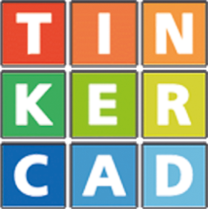

3D modelling programs | Advantages | Disadvantages
AutoDESK Fusion 360 | User friendly  Price free for students 3 years  It has a lot of different free parts (CAM, CAD etc.)  Cloud based exchange and storage system  Considered industry standard software  Useful for basic and easy-to-use simulations | Offers intuitive assembly interface
Blender | Free (Open source)  Good for small teams or freelancers  Has CAD features to repair your meshes | Not easy for beginners.
Catia V5  Student Edition | Useful for big project like automation system of factory | Price $110 for each student  Modular costs (Mechanical design part, assembly etc.)  Complex 3D modelling program for design and assembly  High spec PC required such as i5 CPU, 1GB display card etc.
PTC Creo Parametric Essentials | It is easy to go back to the design board. Because it is parametric program so when you change a value of your design.  It changes automatically the part area.  Fast creation  Flexible modelling | It is different program for design than others meaning it is unfamiliar and hard to learn.  Price $7,699, and it has no student edition option

3D modelling programs | Advantages | Disadvantages
Sketchup Design | Price free for users  User friendly  Easy learning curve  High quality  For large or medium companies | Some limitations with free version
Solid Works Student Edition | Useful for big machine design and more  Easy and simple smooth transition  Offers robust simulation packages | Price $86 for each student per a year  Complex 3D modelling program for design  High spec PC required such as at least 1GB graphics
TinkerCad 123D | Very User friendly, for kids 4 years and over (therefore simplistic functionality)  Enjoyable interface for kids  Price free for users | Low functionality for design and assembly area so difficult to build specific or complicated parts  Will not be updated anymore

Table-1: Comparison of 3D modelling programs

4.2 Comparison of slicing programs
The 3D models must be first sliced into layers since the 3D printer prints out model layer by layer. The slicing algorithm plays a very important role in the 3D printing process. The most common technique for slicing is the produce contour data from STL files. The software then generates the tool path (.gcode) the printer will use for printing. Most slicing software will have a print preview function to help you prevent print failures.

Slicing Programs | Advantages | Disadvantages
Cura | User friendly  Simple interface  Free for users  Detailed enough  Open source  Inspect all the layers to if the slicing is done correctly  Intelligent tool path  Fast print speed | Poor support quality for printing
Craftware | A lot of detailed support  Free for users | Complicated
Simplyfy3D | A lot of detail  Good quality printing | Complicated  149$
Slic3r | Simple interface  Normal printing quality  Free for users | Poor quality support for printing  Not as complicated  Some errors on thin walled parts
Table-2: Comparison of slicing programs

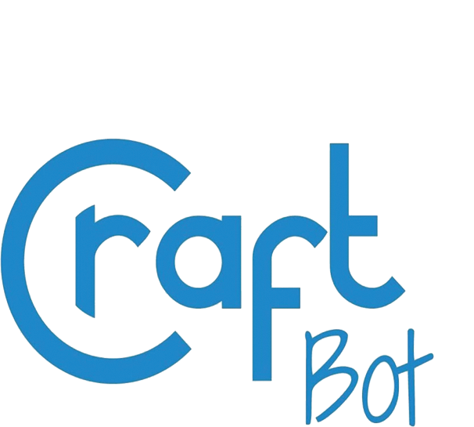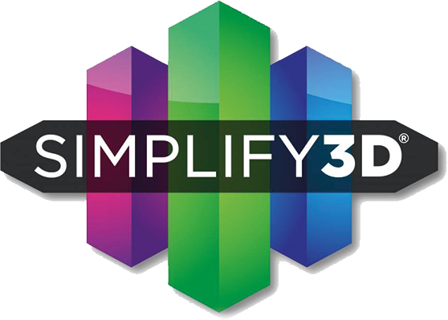

4.3. Comparison of 3D printers

3D printing or additive manufacturing is a process of making three dimensional solid objects from a digital file. The creation of a 3D printed object is achieved using additive processes. In an additive process an object is created by laying down successive layers of material until the object is created. Each of these layers can be seen as a thinly sliced horizontal cross-section of the eventual object.

You can use 3D printers to create everything, from toys to prototypes. These days, some people are even using 3D printers to churn out protective gear related to the coronavirus pandemic. And with that kind of flexibility, it's no surprise that 3D printers have found a place in classrooms, design shops and even homes of hobbyists and makers.

But with a wide range of users comes an even wider range of printers. 3D printers come in all shapes and sizes, with prices ranging from a couple hundred Euros to four-figure price tags.

Printers | Advantages | Disadvantages
Anycubic Prusa i3  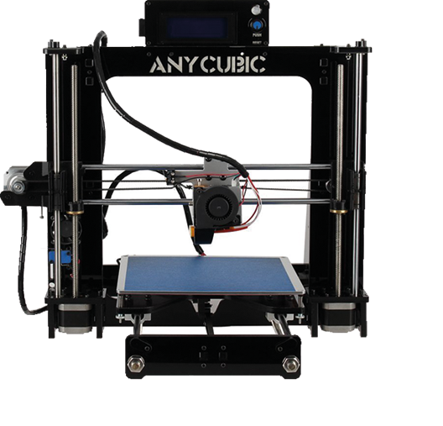 | Build volume: 200x200x200mm  Minimal assembly  100-600 micron layer resolution  Works with all filaments  SD-Card and computer connectivity  All spare parts are cheap and very common  $500  Fast and responsive user interface | Single extrusion  Normal printing quality  Somewhat noisy  Not very upgrade-friendly

Printers | Advantages | Disadvantages
Makerbot Replicator  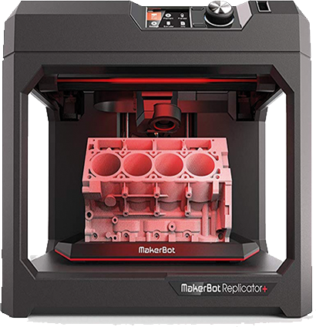 | Flexible connectivity (WiFi, Ethernet, USB)  Build volume: 52.8x44.1x41.0  100micron layer resolution  Good printing quality  Box body  Fast print speed  Simple to use | Only use Makerbot filament (expensive)  Only use Makerbot slicing firmware  Not easy to reach spare parts  $800
Robox Dual  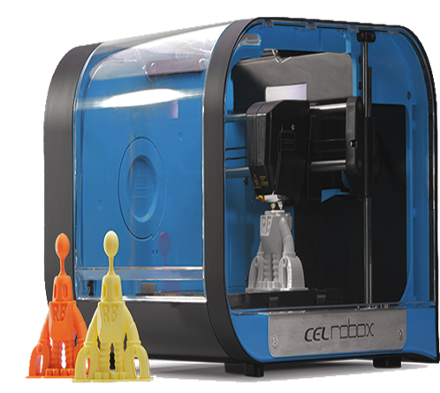 | Dual extrusion  Box body (low noise)  Good printing quality  Min. layer resolution 20 micron  Supports open source hardware and software | 210x150x100mm (small plate for printing)  Not easy to reach spare parts  Limited resolution  £1000  Basic interface  Open frame design
Ultimaker 2+  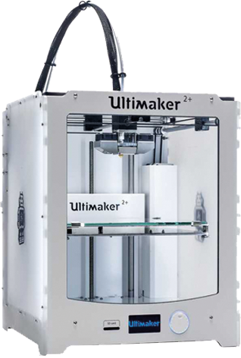 | Build volume: 22.3x22.3x20.5  Good Printing quality  Layer resolution 20-600 micron  Works all slicing programs  No limitation on modifying a device and the use of any slicer wanted  Open source | Single extrusion  Not easy to reach spare parts (expensive)  SD-Card connectivity  £2750
Zortrax M200  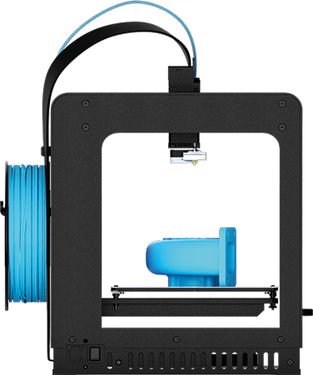 | Build volume:20x20x18cm  90-400 micron layer resolution  Good printing quality  Box body  For professional applications  Infallible  Convenient maintenance | Single extrusion  Only use own filament  Only use own slicing firmware  SD-Card connectivity  Not easy to reach spare parts  1000$  Any modifications are very limited  Not open-source

Printers | Advantages | Disadvantages
ELegoo Mars UV SLA  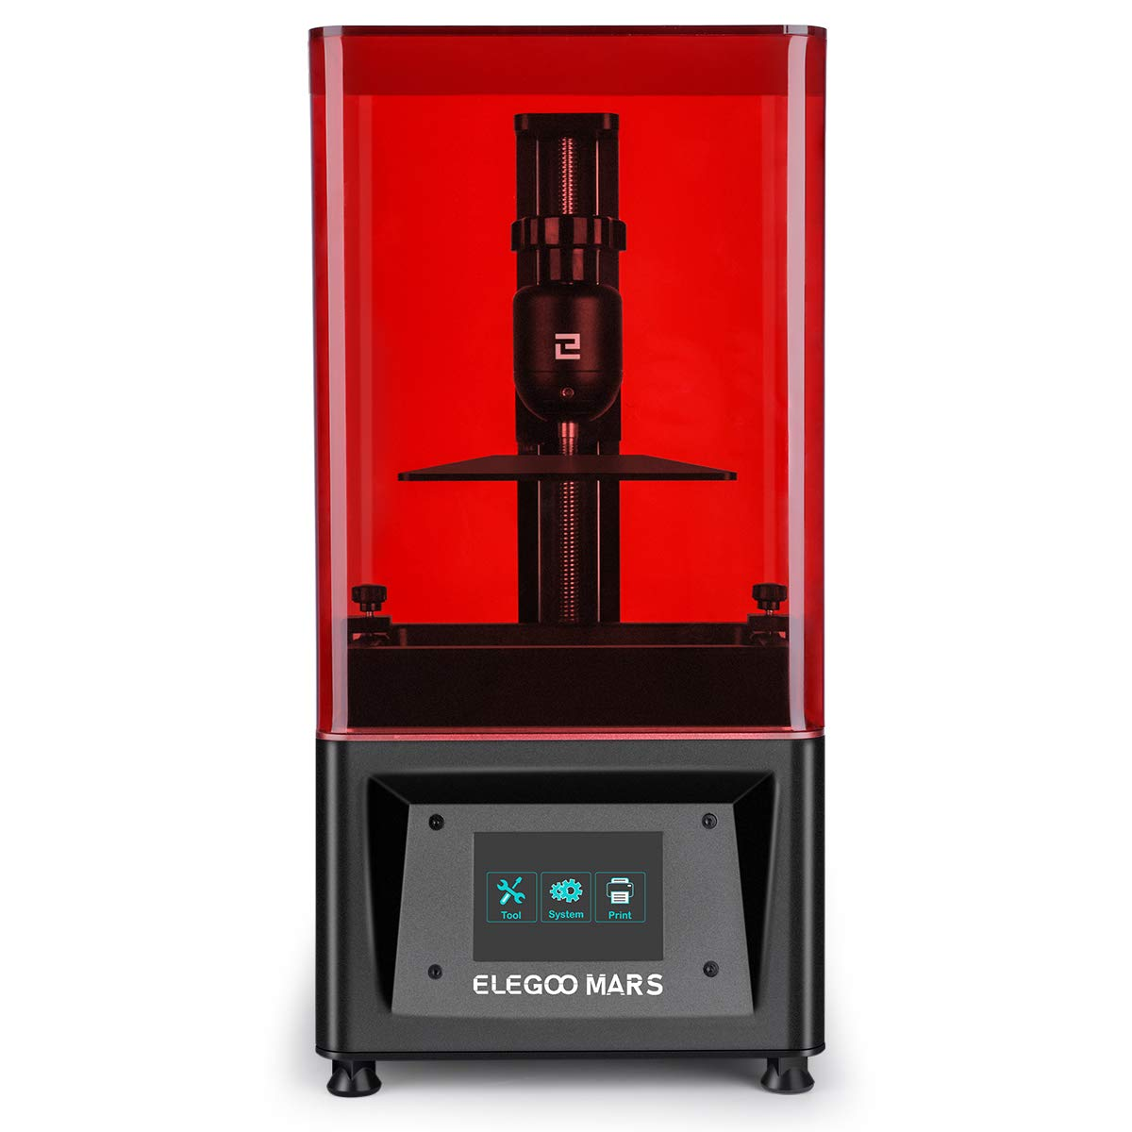 | Great budget resin 3D Printer  Excellent print quality  Minimal setup  Simple but effective  Build volume:12x6.8x15.5mm  2560 x 1440 pixels, 10 microns resolution | Basic connectivity (USB) in an awkward location  The fan is quite loud  Prolonged use can trip the firmware up
Anycubic Predator Delta  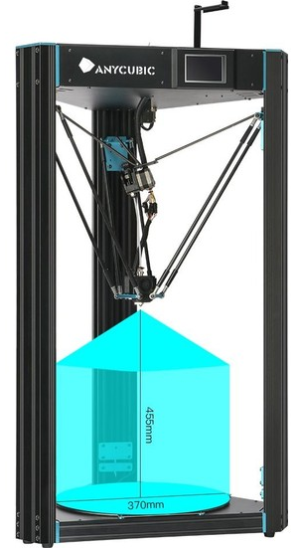 | Heavy duty DELTA structure, Minimum shaking during printing  Easy levelling, save your much time and effort on print bed levelling  Build volume:37x45.5cm  Layer Resolution: 0.05-0.3 mm  High-precision and stability | Some issues with the controller

Table-3: Comparison of 3D printers

